SHREEJI CORPORATION LOGO DESIGN QUESTIONNAIRE

Describe what you want designed

- Project Name:
(Is this a business logo, a personal monogram, or a symbol? What is your name /company name?)

- Design Text:
(This is the text of your logo or design. It should include your company name or personal name or initials- whatever you want to appear in the design.)

- Tagline, if any:

- Describe who/what this design is about:
(If this is for a business, tell us about your company. If this is for a person, describe who the design is going to be used for, and where it will be used. Feel free to post any URLs to your website, or other websites designers can use as inspiration.)

- Industry Type:
(If this logo is for your business, please mention Industry that best describes your business/organization or profession. If it is a personal logo or monogram, use word "Personal")

- What would you like to communicate to your audience through your design? :
(Tell us what you want your audience to think when they see your design.
What impression or attitude do you want to convey? Use descriptive words such as Serious, Funny, Creative.....
It may help to describe who your audience is - young, old, men, women, shoppers, musicians)
- How would you describe the effect in your logo:(Check all that apply):

- What kind of design are you looking for?:

Design is based on the Name/Company, and is written in stylized face type and may include minor abstract elements

A symbol, icon, or abstract image to represent you / your business


Contains an abstract element to convey an idea or attribute about the organization.
Famous examples include
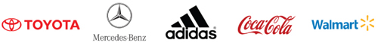

Represents you or your company’s message by using the initial letters of business name
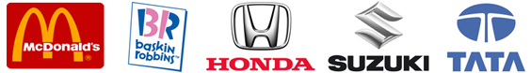

Design is based on an illustration or an image. For best results please keep the price above $400
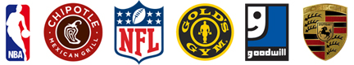

A Character logo design consists of a mascot to represent the brand. Please note that Character
illustrations are extremely labor intensive for designers and for the best results the prize should
be at least $400-$500. Famous examples include
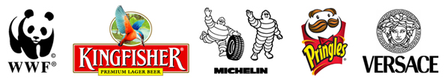

A new trend originated by the combination of 3D style, vivid colors, special effects, lowercase
letters, and shadows ( Extra Cost Around USD 200 )
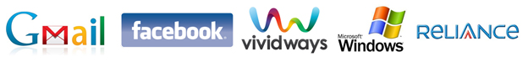

- How many colors do you want in your design?:

- What colors would you like?:
If you want a particular shade, you can list a URL for another website or design which uses that color.

- Do you have any additional suggestions or ideas?:
Please provide any additional information and reference URL of ideas that you think will be useful for the designers. You can also provide details of what you want to avoid - such as a competitor's logo, or an overused design.

- Need a web solution?:
We are providing affordable web solutions that are perfect for businesses of all sizes.

Note: Your information will only be sent to the sales team at Shreeji Corporation, and will not be shared with outside parties at any time without your permission.
Thank you for filling up Logo Questionnaire and your time.

